JS Advanced Materials Laboratory

Experiment: Determination of the average molar mass of a macromolecule by solution viscometry.

In this experiment, we use solution viscometry to determine the molar mass
of a macromolecule.

Introduction.

Some biopolymers such as proteins are true chemical compounds in the strictest sense, with all their molecules having identical molar masses as well as identical physical and chemical properties. Synthetic polymers however, being formed by random polycondensations or polyadditions, are essentially mixtures of homologues, exhibiting a distribution of chain lengths and hence molar masses. Now chemical properties are usually approximately independent of molar mass since any differences shown by the end groups are usually undetectable except by special techniques. The physical properties however are often very sensitive to molar mass, and according to the property may be determined by different averages of the molar mass distribution.

Two types of average molar mass are usually described. The first is the number average molar mass <M_{n}> defined as:
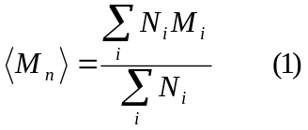
where N_{i} denotes the number of molecules in the sample of molar mass M_{i}. This average is the relevant parameter for any property that depends only on molar concentration (the number of particles present in a given volume). It can be obtained by determining the colligative thermodynamic properties of a polymer solution. Properties which depend not only on the number of particles per unit volume but also on their size are determined by the weight average of the molar mass distribution and we define a weight average molar mass <M_{w}> as :
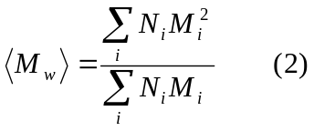
Note that <M_{w}> values are determined from light scattering experiments.

We notice that <M_{w}> is greater than <M_{n}> and we can introduce the ratio

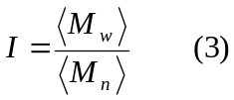

This ratio termed the polydispersity index is a measure of the breadth of the molar mass distribution. This ratio can be as low as 1.02- 1.05, but only for one specific mechanism of polymerization ("living" polymerizations). Often it is close to 2, but for commercial polymer samples I can be much higher.

A characteristic feature of a dilute polymer solution is that its viscosity is considerably higher than that of either the pure solvent or similarly dilute solutions of small molecules. This arises because of the large differences in size between polymer and solvent molecules, and the magnitude of the viscosity increase is related to the dimensions of the polymer molecules in solution. Therefore measurements of the viscosities of dilute polymer solutions can be used to provide information concerning the effects upon chain dimensions of polymer structure (chemical and skeletal), molecular shape, degree of polymerization (hence molar mass) and polymer-solvent interactions. Most commonly, however, such measurements are used to determine the molar mass of a polymer.

The quantity or greatest importance for the purposes or polymer characterization is the intrinsic viscosity [η] since this quantity relates to the intrinsic ability or a polymer to increase the viscosity of a particular solvent at a given temperature. The specific viscosity η_{s} of a solution of concentration c is related to the intrinsic viscosity [η] by the following expression :

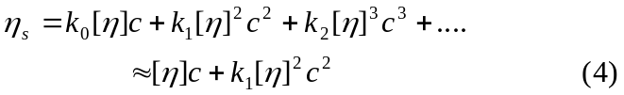

where k₀, k_{l}, k₂ are dimensionless constants and we set k₀ = 1. In eqn.4 we have truncated the power series expansion and considered only terms to second order in c. We rearrange eqn.4 to :

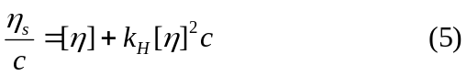

This expression is known as the Huggins equation and is valid for [η]c « 1. The Huggins constant k_{H} = k₁ is essentially independent of the molar mass and has values which lie in the range 0.3 (good polymer / solvent pairs) to 0.5 (poor polymer / solvent pairs).

We can also define the relative viscosity or viscosity ratio η_{r} as η_{r} = η/η₀ where η₀ denotes the solvent viscosity. Note that η_{r} and η_{s} are related via :

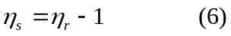
For dilute solutions with η_{s} <<1, we note

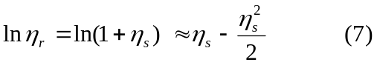

Substituting eqn.5 into eqn.7 and retaining only terms in c up to second order we obtain:
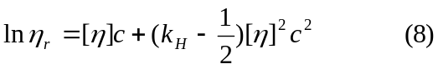
This expression may be rearranged to give the Kraemer equation:

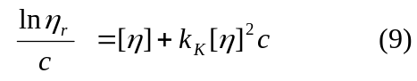

where the Kraemers constant k_{K} is given by k_{K} = k_{H} - ½ and so will be negative or zero.
Although there are other simplifications available, the Huggins and Kraemer equations provide the most common procedure for evaluation of [η] from experimental data. This involves a dual extrapolation according to these equations and gives [η] as the mean intercept, as presented in fig. 1 below.

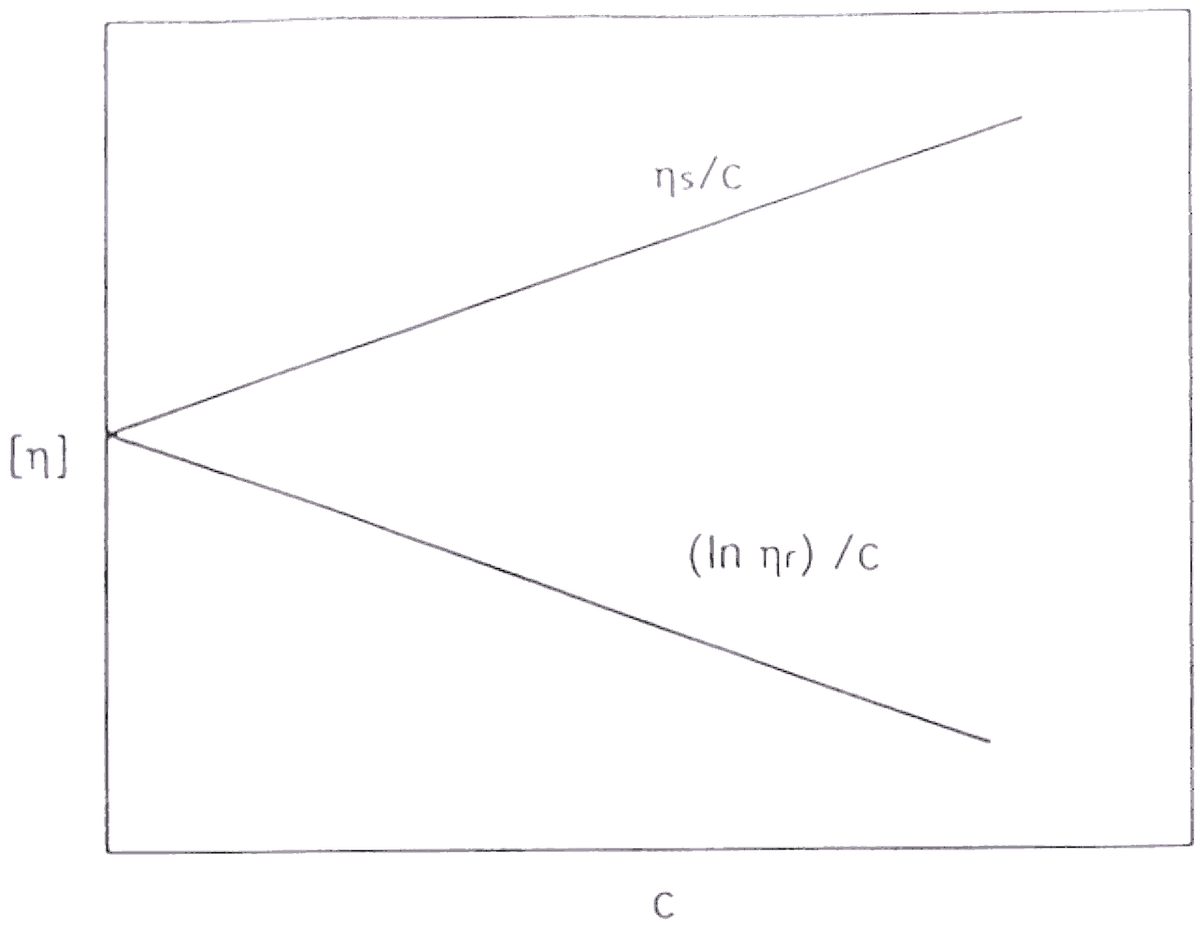

Now the intrinsic viscosity [η] of a polymer is related to its viscosity average molar mass <M_{v}> by the Mark-Houwink equation :

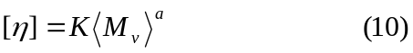
where K and a are characteristic constants for a given polymer/solvent/temperature system. In particular a depends on the rigidity of the polymer chain. For stiff, rod like chains we find that 1 < a < 2, whereas for most polymers with a flexible carbon atom main chain we find 0.5 < a < 0.8.

The form of <M_{v}> may be deduced as follows. Specific viscosities are additive in the limit of infinite dilution. Hence we write :
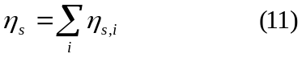
where η_{s,i} is the contribution to η_{s} made by n_{i} moles of polymer molecules of molar mass M_{i} present in unit volume of a dilute polymer solution. Since c_{i} = n_{i} M_{i} and η_{s,i} = c_{i} [η_{i}] and [η_{i}] = K M_{i}ª, then :

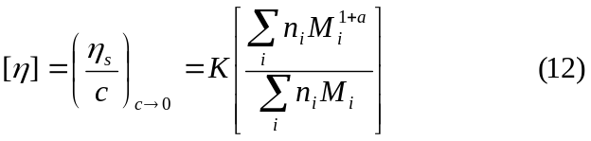

Comparing this expression with that outlined in eqn.10 we find that:

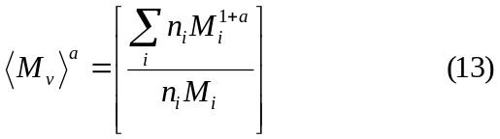

Thus for gaussian coils <M_{v}> lies between <M_{n}> and <M_{w}> . When a = 1 which is observed for stiff or highly extended chains <M_{v}> = <M_{w}>

In order to evaluate <M_{v}> from [η] using the Mark-Houwink equation, it is necessary to know the values of K and a for the system under study. Specifically for poly(styrene) in THF at 298 K (the system being examined in this experiment) we note that (see Polymer. 20 (1979) 437, Spychaj et al.) :

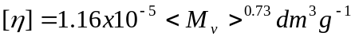

Experimental Procedure:

Weigh accurately into a 10 cm³ volumetric flask ca. 300 mg of the poly(styrene) sample. Dissolve in dry THF. Note that the polymer dissolves quite slowly and that in most cases this is preceeded by swelling. This stock solution is to be used for the viscometry experiments.

Ensure that the viscometer is clean and dry. Measure the flow times t of (i) the THF solvent 15 cm³ of which have been measured accurately by means of a pipette; (ii) the solvent 15 cm³) to which has been added 1 cm³ of the stock polymer solution; (iii) the latter solution plus a further 1 cm³ of the polymer solution; (iv) the latter solution plus a further 2 cm³ of stock polymer solution. Continue this procedure until 6 data points are obtained.

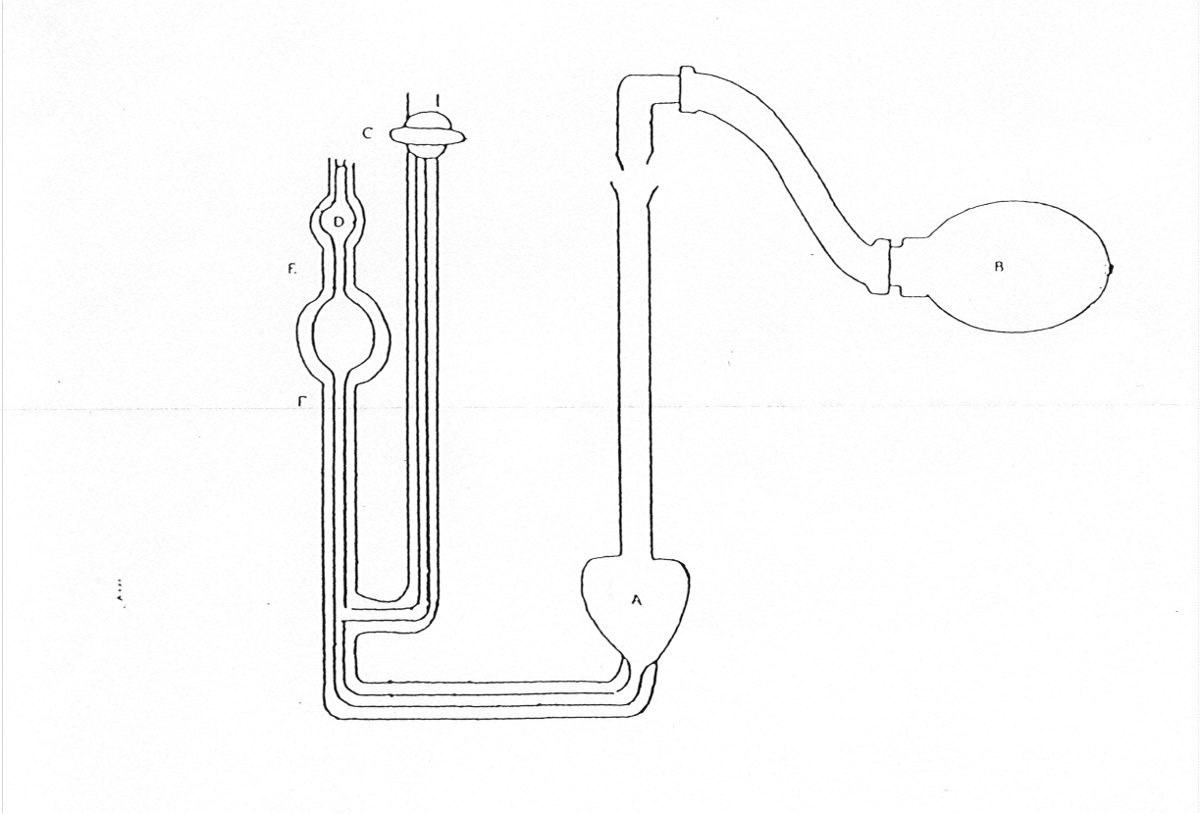
An Ubbelohde viscometer is used in the experiment. This is illustrated in fig.2 below

We now describe the flow time measurement. With the viscometer rigidly clamped in position in the thermostat bath and observable through the glass panel, introduce the requisite quantity of the solution (via pipette) into bulb A. After attainment of thermal equilibrium, close tap C and use the rubber bulb to raise the column of liquid up the left hand limb until its surface lies in the bulb D. Detach the blower assembly from the right hand limb and open tap C. Measure the flow time, i.e., the time taken for the surface to travel between the etched marks E and F, as accurately as possible (use a Stop watch). Measurements should be repeated until three values, consistent to 0.2 seconds are obtained.

Note that all liquids used in this experiment (THF and stock polymer solution) should be kept in the thermostat bath when not in use.

The concentration of the solution can then be changed by adding the requisite amount of solvent or stock polymer solution to the bulb B and mixing thoroughly before re-thermostating in preparation for the next run.

Data Analysis.

Determine the relative viscosity η_{r} of each solution. Note that η_{r} = η / η₀ = t / t₀ where t₀ represents the flow time of the pure solvent. From this data calculate η_{s} = η_{r} -1 for each solution.

Plot η_{s} / c and ( ln η_{r}) / c versus the concentration c (note that c should be expressed in g dm⁻³ assuming that the volumes are additive). Each plot should be linear with an infinite dilution value of the intrinsic viscosity [η] .Determine the slopes of each plot (yielding k_{H} and k_{K}) and verify that k_{H} -k_{K} = 0.5.

Use the Mark -Houwink equation to calculate <M_{v}> the viscosity average molar mass.

JS Advanced Materials

Laboratory

Experiment: Determination of the conformation of macromolecules in solution using dilute solution viscometry.

Introduction.

In this experiment a somewhat different mode of presentation is adopted. We include a reprint from the Journal of Chemical Education (D. H. Napper, J. Chem. Educ, 46 (1969) 305). You are expected to read this paper critically and perform the experiments, and to do the calculations as indicated. This will give you some insight into working methods used by research workers, as these people do not have a lab manual to follow when carrying out experiments. You should look up citations and primary references where necessary.

